1)Introduction to Ansible Vault and Secret Storage

What is Ansible Vault?
Ansible Vault is a feature of Ansible used to protect sensitive information by encrypting it.
For example, Ansible playbooks and variable files may contain sensitive information such as:
- Passwords
- SSH keys
- API tokens
- Database passwords
- Cloud credentials
- Secret variables
Instead of storing these values as plain text, we can use Ansible Vault to encrypt them.

Simple meaning
Ansible Vault = A tool used to encrypt and protect secrets used by Ansible.

Why do we need Ansible Vault?
Suppose you create a variable file:
db_password: MyPassword123
Anyone who can read this file can see the password.
❌ Not secure
With Ansible Vault, the file is encrypted:
db_password
↓
Ansible Vault
↓
Encrypted file
↓
Password is protected

Secret Storage
Secret storage means keeping sensitive information in a secure place instead of directly putting it in your playbook.
For example, instead of:
vars:
username: admin
password: MyPassword123
you can store the password in an encrypted Vault file.
A common structure is:
/home/ansible/
│
├── playbook.yml
│
└── group_vars/
└── dev1/
└── vault.yml
The vault.yml file contains sensitive variables and is encrypted using Ansible Vault.

Simple Example
Suppose you want to store a password.
Create a Vault file:
ansible-vault create secret.yml
Ansible asks you for a Vault password.
Inside the file, write:
username: admin
password: Linux@123
Save and exit.
The file is now encrypted.
If you run:
cat secret.yml

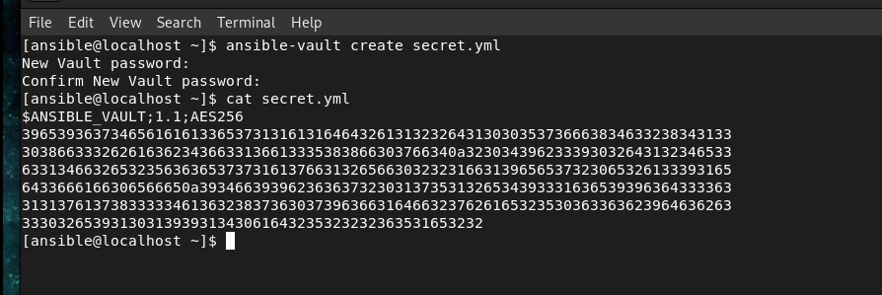
you will see encrypted content instead of:
password: Linux@123

How do we use the Vault file?
Suppose your playbook is:
---
- name: Vault example
hosts: dev1

vars_files:
- secret.yml

tasks:
- name: Display username
ansible.builtin.debug:
msg: "Username is {{ username }}"
Run:
ansible-playbook -i /etc/ansible/hosts vault.yml --ask-vault-pass
Ansible asks:
Vault password:
Enter the password you used when creating the Vault file.
Ansible can then decrypt secret.yml and use the variables.
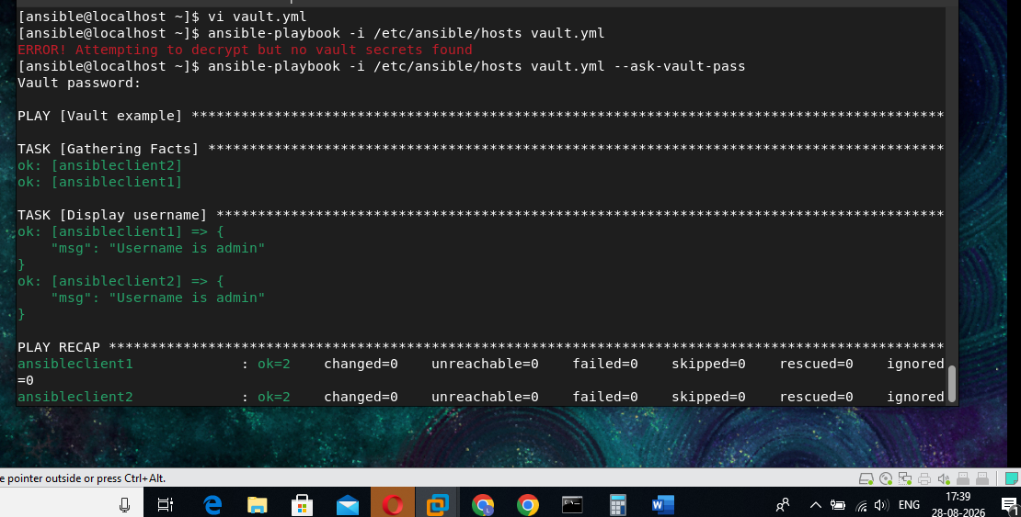

Important Vault Commands

Create an encrypted file
ansible-vault create secret.yml

View an encrypted file
ansible-vault view secret.yml
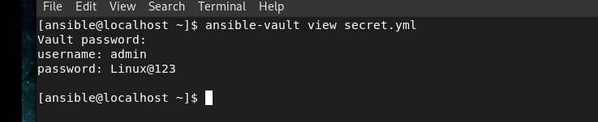

Edit an encrypted file
ansible-vault edit secret.yml
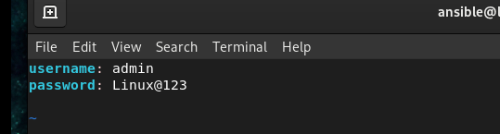

Encrypt an existing file
ansible-vault encrypt secret.yml
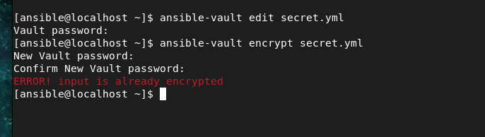

Decrypt a file
ansible-vault decrypt secret.yml
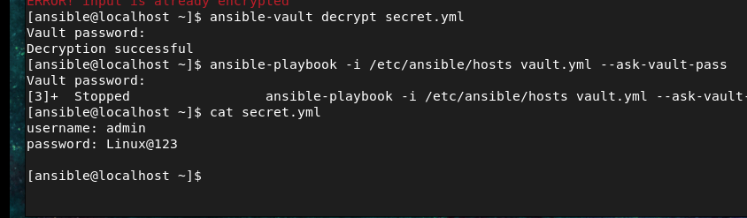

Change Vault password
ansible-vault rekey secret.yml

2) What are Ansible Facts?
Ansible Facts are information that Ansible automatically collects from the managed hosts when it connects to them.
In simple words:
Ansible Facts = Information about the remote server collected by Ansible.
For example, Ansible can collect information about:
- Operating system
- Hostname
- IP address
- CPU
- RAM
- Disk
- Kernel version
- Python version
- Network interfaces
- Architecture

Example with your environment
You have:
dev1
├── ansibleclient1
└── ansibleclient2
When you run a playbook:
---
- name: Facts example
hosts: dev1

tasks:
- name: Display operating system
ansible.builtin.debug:
msg: "Operating system is {{ ansible_facts['distribution'] }}"
Run:
ansible-playbook -i /etc/ansible/hosts facts.yml
Because your clients are Ubuntu, you might get:
ok: [ansibleclient1] => {
"msg": "Operating system is Ubuntu"
}

ok: [ansibleclient2] => {
"msg": "Operating system is Ubuntu"
}

Where did distribution come from?
Ansible automatically collected it when it performed:
TASK [Gathering Facts]
For example:
TASK [Gathering Facts]
ok: [ansibleclient1]
ok: [ansibleclient2]
Ansible then makes the information available through:
ansible_facts

Some useful facts
You can display individual facts:

Hostname
{{ ansible_facts['hostname'] }}

Operating system
{{ ansible_facts['distribution'] }}

OS version
{{ ansible_facts['distribution_version'] }}

Architecture
{{ ansible_facts['architecture'] }}

IP address
{{ ansible_facts['default_ipv4']['address'] }}

Small practical example
Create:
vi facts.yml
---
- name: Display server information
hosts: dev1

tasks:
- name: Show server information
ansible.builtin.debug:
msg:
- "Hostname: {{ ansible_facts['hostname'] }}"
- "OS: {{ ansible_facts['distribution'] }}"
- "Version: {{ ansible_facts['distribution_version'] }}"
- "Architecture: {{ ansible_facts['architecture'] }}"
Run:
ansible-playbook -i /etc/ansible/hosts facts.yml

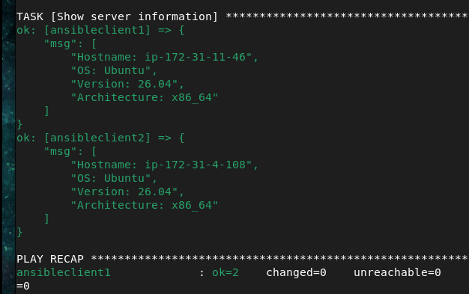
You will get information about each client.

Why are Facts useful?
Facts are especially useful when you want Ansible to make decisions based on the target machine.
For example:
when: ansible_facts['distribution'] == "Ubuntu"
means:
Run this task only if the machine is Ubuntu.
You could have:
- name: Install Apache on Ubuntu
ansible.builtin.apt:
name: apache2
state: present
when: ansible_facts['distribution'] == "Ubuntu"
This is useful when your inventory contains different Linux distributions.

